Observation File

1 Task-01

When we run the following program

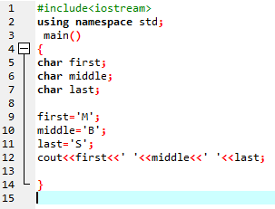

We get the following output

1. When we initialize character variables using single quotes we get the following output:

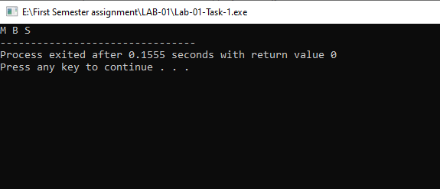

1. When we initialize using single quotes following error occurred



So we observe that we can store a variable in character only by using single quotes.

2 Task-02

When we run the following program:

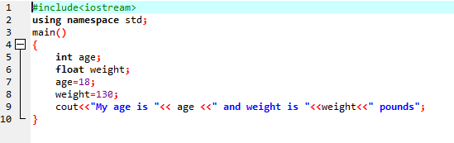

We get the following output:

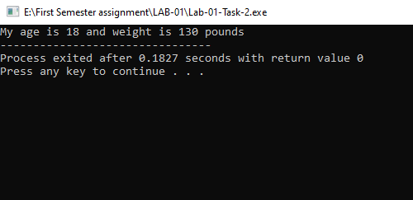

3 Task-03

When we run the following program:

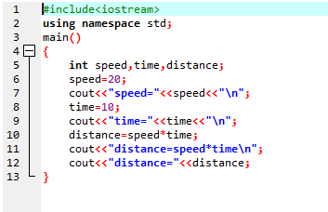

We get the following output:

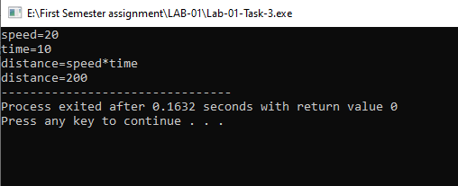

4 Task-04

When we run the following program:

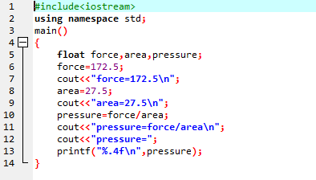

We get the following output:

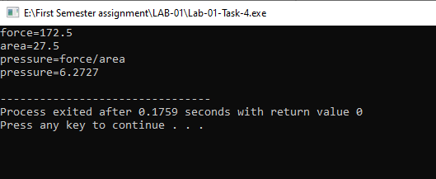

5 Task-05

When we run the following program:

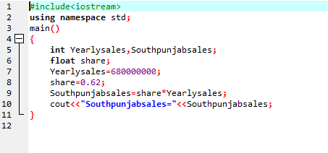

**We** get the following output:

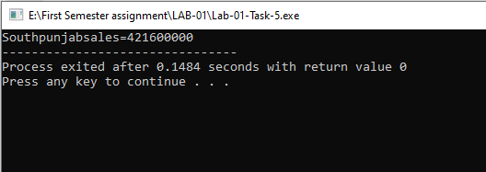

6 Task-06

When we run the following program to calculate the bill:

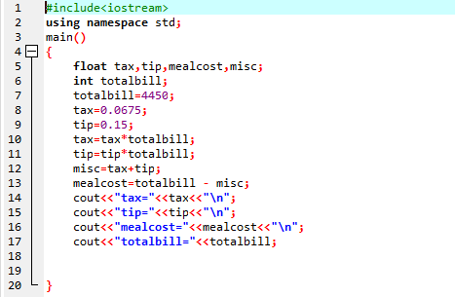

In return we will get the following result in the form of result:

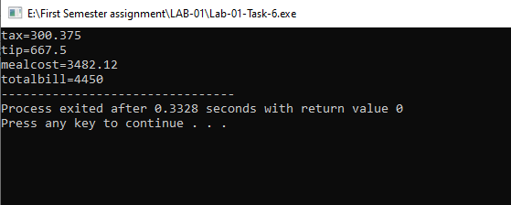

7 Task-07

When we run the following program to solve the required problem:

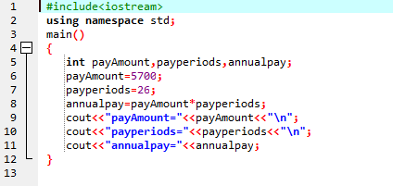

We get the solution of the required problem:

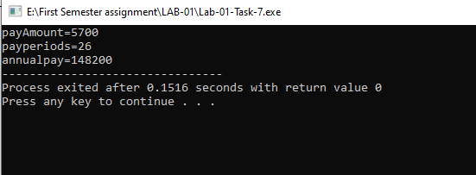

8 Task-08

First of all we write a pseudo code and then write a C++ program to calculate ocean level like this:

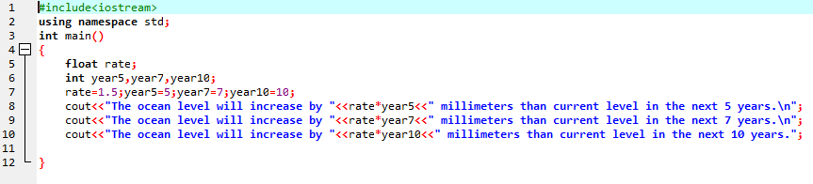

9 Task-09

When we write a program to calculate the acres we will get the following program:

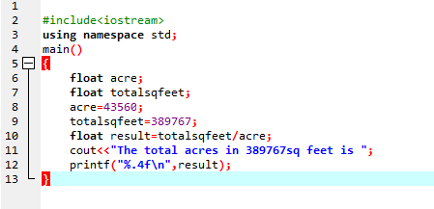

We will get required answer in this form:

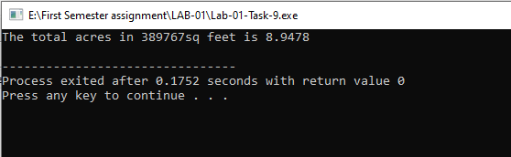

For limiting digits after decimals we will use print f command.

10 Task-10

For the calculation of the commission , Total amount paid inclusive of taxes and exclusive of taxes we will write the program in this way:

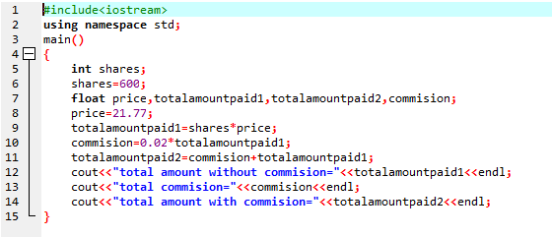

We will get our problem solved and get our result:

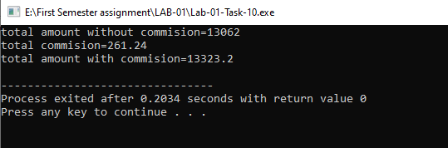

11 Task-11

To calculate the costumer of a beverage company the we write the following program :

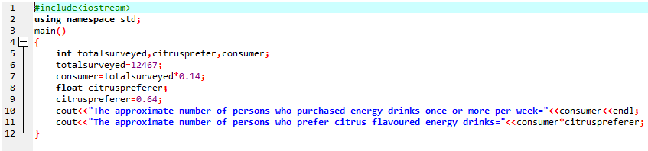

We will get the our required output:

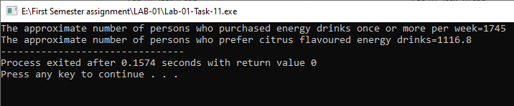

The end